SQL Server Index Analysis and Optimization
https://towardsdatascience.com/sql-server-index-analysis-and-optimization-1edd84d9da
Quite often there is a need to optimize indexes and statistics for quicker search for the necessary data and better construction of a query execution plan by an optimizer.
The following areas of work can be understood as index optimization:
- creation of missing indexes
- removal of overlapping indexes
- removal of unused indexes
- change of existing indexes in order to fit operating conditions changed over time (structures of key columns, structures of included columns, and properties of an index itself)
- removal of those indexes for which servicing costs are significantly greater than their benefit for optimization under the operating conditions that have changed over time
- indexes reorganization and rebuilding.

SQL Server Index Analysis
The level of index fragmentation in a database can be analyzed with the help of the following query:
with info as
(SELECT
ps.[object_id],
ps.database_id,
ps.index_id,
ps.index_type_desc,
ps.index_level,
ps.fragment_count,
ps.avg_fragmentation_in_percent,
ps.avg_fragment_size_in_pages,
ps.page_count,
ps.record_count,
ps.ghost_record_count
FROM sys.dm_db_index_physical_stats
(DB_ID()
, NULL, NULL, NULL ,
N'LIMITED') as ps
inner join sys.indexes as i on i.[object_id]=ps.[object_id] and i.[index_id]=ps.[index_id]
where ps.index_level = 0
and ps.avg_fragmentation_in_percent >= 10
and ps.index_type_desc <> 'HEAP'
and ps.page_count>=8 --1 экстент
and i.is_disabled=0
)
SELECT
DB_NAME(i.database_id) as db,
SCHEMA_NAME(t.[schema_id]) as shema,
t.name as tb,
i.index_id as idx,
i.database_id,
(select top(1) idx.[name] from [sys].[indexes] as idx where t.[object_id] = idx.[object_id] and idx.[index_id] = i.[index_id]) as index_name,
i.index_type_desc,
i.[object_id],
i.fragment_count as frag_num,
round(i.avg_fragmentation_in_percent,2) as frag,
round(i.avg_fragment_size_in_pages,2) as frag_page,
i.page_count as [page]
FROM info as i
inner join [sys].[all_objects] as t on i.[object_id] = t.[object_id];

The following columns are returned:
- db — database name
- schema — schema object (table, view)
- tb — table/view where the index is located
- idx — index ID
- database_id — database ID
- index_name — index name
- index_type_desc — index type description
- object_id — object ID (table, view) where the index is located
- frag_num — the number of fragments at the final level of the allocation unit
- frag — average percentage of available disk space used by all pages
- frag_page — average number of pages in one fragment at the final level of the allocation unit IN_ROW_DATA
- page — total number of index pages or data
This shows the level of fragmentation of the indexes which size is no less than 1 extent (8 pages) and which fragmentation is more than 10%. It works only for tables with a clustered index, and only root indexes are taken into account. This query uses two system views:
- sys.dm_db_index_physical_stats — returns information about the size and fragmentation of data and indexes of the specified table or view in SQL Server.
- sys.indexes — contains a row for each index or heap of a table object, such as a table, a view, or a table-valued function.
Next, let’s consider when index optimization is recommended and how to perform it.

SQL Server Indexes Optimization
In the previous query, two indicators are particularly important:
- frag — the level of index fragmentation in percent
- page — index size in total number of its pages
There are different approaches to the interpretation of the level of index fragmentation and index optimization methods. One of them will be considered in this article.
The index needs to be optimized if:
- its size exceeds 8 pages and its level of fragmentation is more than 30%.
- its size exceeds 64 pages and its level of fragmentation is more than 25%.
- its size exceeds 1 000 pages and its level of fragmentation is more than 20%.
- its size exceeds 10 000 pages and its level of fragmentation is more than 15%.
- its size exceeds 100 000 pages and its level of fragmentation is more than 10%.
Two approaches can be used for index optimization:
1. Index reorganization
Index reorganization requires a minimum amount of system resources. During reorganization, the leaf level of clustered and nonclustered indexes in tables and views is defragmented by means of physical reorganization of the leaf level pages. As a result, they become arranged in accordance with the logical order of the leaf nodes (from left to right). In addition, the reorganization compresses the index pages. Their compression is performed in accordance with the current value of the fill factor.
You can perform index reorganization with the help of the following command:
ALTER INDEX < index_name> ON <schema>.<table> REORGANIZE;
2. Index rebuilding
Rebuilding removes an old index and creates a new one. This eliminates fragmentation, restores disk space by means of compressing pages to the specified or existing fill factor, reorders index rows in consecutive pages, and updates the new index statistics.
You can perform index rebuilding with the help of the following command:
ALTER INDEX < index_name> ON <schema>.<table> REBUILD;
If your edition of the MS SQL Server supports that, the index rebuilding can be done online:
ALTER INDEX <index_name> ON <schema>.<table> REBUILD WITH(ONLINE=ON);
More information about ALTER INDEX command can be found here.
There are many index optimization tools both free and fee-based. For example, Sergey Syrovatchenko is developing a fairly powerful and free tool for optimizing indexes.
The advantages of this tool are as follows:
- optimized algorithm for obtaining fragmented indexes
- ability to serve multiple databases at once in one process
- automatic action selection for indexes based on selected settings
- support for global search and advanced filtering for better analytics
- a lot of settings and useful information about indexes
- automatic generation of index maintenance scripts
- support for heap and column index maintenance
- ability to enable index compression and statistics update instead of rebuilding
- support for all editions of SQL Server 2008 and later, as well as the Azure SQL Database.
The detailed discussion about the tool can be found here.

Statistics Analysis and Optimization
Let’s consider one of the methods to determine obsolete statistics:

declare
--Maximum size in MB for the object in question
@ObjectSizeMB numeric (16,3) = NULL,
--Maximum number of rows in the section
@row_count numeric (16,3) = NULL;
;with st AS(
select DISTINCT
obj.[object_id]
, obj.[create_date]
, OBJECT_SCHEMA_NAME(obj.[object_id]) as [SchemaName]
, obj.[name] as [ObjectName]
, CAST(
(
--the total number of pages reserved in the section (8 KB for 1024 divided = divide by 128)
SELECT SUM(ps2.[reserved_page_count])/128.
from sys.dm_db_partition_stats as ps2
where ps2.[object_id] = obj.[object_id]
) as numeric (38,2)
) as [ObjectSizeMB] —object size in MB
, s.[stats_id]
, s.[name] as [StatName]
, sp.[last_updated]
, i.[index_id]
, i.[type_desc]
, i.[name] as [IndexName]
, ps.[row_count]
, s.[has_filter]
, s.[no_recompute]
, sp.[rows]
, sp.[rows_sampled]
--the number of changes is calculated as:
--the sum total of changes in the initial statistics column since the last statistics update
–and remainder of the approximate number of rows in the section and the total number of rows in the table or indexed view after the last statistics update
, sp.[modification_counter]+ABS(ps.[row_count]-sp.[rows]) as [ModificationCounter]
--% number of rows selected for statistical calculations,
--to the total number of rows in the table or indexed view after the last statistics update
, NULLIF(CAST( sp.[rows_sampled]*100./sp.[rows] as numeric(18,3)), 100.00) as [ProcSampled]
--% sum total of changes in the initial statistics column since the last statistics update
--to the approximate number of rows in the section
, CAST(sp.[modification_counter]*100./(case when (ps.[row_count]=0) then 1 else ps.[row_count] end) as numeric (18,3)) as [ProcModified]
--Object weight:
--[ProcModified]*decimal logarithm of the approximate number of rows in the section
, CAST(sp.[modification_counter]*100./(case when (ps.[row_count]=0) then 1 else ps.[row_count] end) as numeric (18,3))
* case when (ps.[row_count]<=10) THEN 1 ELSE LOG10 (ps.[row_count]) END as [Func]
--whether the scanning has been performed:
--the total number of rows selected for statistical calculations is not equal to
--the total number of rows in the table or indexed view after the latest statistics update
, CASE WHEN sp.[rows_sampled]<>sp.[rows] THEN 0 ELSE 1 END as [IsScanned]
, tbl.[name] as [ColumnType]
, s.[auto_created]
from sys.objects as obj
inner join sys.stats as s on s.[object_id] = obj.[object_id]
left outer join sys.indexes as i on i.[object_id] = obj.[object_id] and (i.[name] = s.[name] or i.[index_id] in (0,1)
and not exists(select top(1) 1 from sys.indexes i2 where i2.[object_id] = obj.[object_id] and i2.[name] = s.[name]))
left outer join sys.dm_db_partition_stats as ps on ps.[object_id] = obj.[object_id] and ps.[index_id] = i.[index_id]
outer apply sys.dm_db_stats_properties (s.[object_id], s.[stats_id]) as sp
left outer join sys.stats_columns as sc on s.[object_id] = sc.[object_id] and s.[stats_id] = sc.[stats_id]
left outer join sys.columns as col on col.[object_id] = s.[object_id] and col.[column_id] = sc.[column_id]
left outer join sys.types as tbl on col.[system_type_id] = tbl.[system_type_id] and col.[user_type_id] = tbl.[user_type_id]
where obj.[type_desc] <> 'SYSTEM_TABLE'
)
SELECT
st.[object_id]
, st.[SchemaName]
, st.[ObjectName]
, st.[stats_id]
, st.[StatName]
FROM st
WHERE NOT (st.[row_count] = 0 AND st.[last_updated] IS NULL)--if there is no data and statistics has not been updated
AND NOT (st.[row_count] = st.[rows] AND st.[row_count] = st.[rows_sampled] AND st.[ModificationCounter]=0)
--if there is data to update (and the data has been changed significantly)
AND ((st.[ProcModified]>=10.0) OR (st.[Func]>=10.0) OR (st.[ProcSampled]<=50))
--restrictions customized in the input parameters
AND (
([ObjectSizeMB]<=@ObjectSizeMB OR @ObjectSizeMB IS NULL)
AND
(st.[row_count]<=@row_count OR @row_count IS NULL)
);

In the method given, obsolete statistics is determined by the following indicators:
- If the data has been changed significantly.
- If statistics has not been updated for a long time.
- If the object size is less than the specified maximum or this maximum is not specified.
- If the number of rows in the section is less than the specified maximum or this maximum is not specified.
The following system views are used in the query:
- sys.dm_db_partition_stats — returns the page and row count information for all sections of the current database.
- sys.objects — database objects.
- sys.stats — statistics for tables, indexes and indexed views.
- sys.indexes — indexes.
- sys.dm_db_stats_properties — returns the statistical properties of the specified database object (table or indexed view) from the current SQL Server database.
- sys.stats_columns — contains one row for each column that is part of the sys.stats statistics.
- sys.columns — columns of all objects with columns.
- sys.types — types of data.
Statistics can be optimized further using the following commands:
IF (EXISTS(SELECT TOP(1) 1 FROM sys.stats AS s WHERE s.[object_id]=<object_id> AND s.[stats_id]=<stats_id>))UPDATE STATISTICS <SchemaName>.<ObjectName> (<StatName>) WITH FULLSCAN;
More information on UPDATE STATISTICS command can be found here.
An Example of Analysis and Optimization of Indices in dbForge Studio for SQL Server
In dbForge Studio for SQL Server, it is possible to analyze and optimize the level of index fragmentation. The product dbForge Index Manager also has this functionality.
In this example, we will consider the SRV database, which is designed to serve MS SQL Server DBMS.
This SRV database is distributed freely for any purpose. After opening the studio, click the “Manage Index Fragmentation …” button on the “Administration” tab:

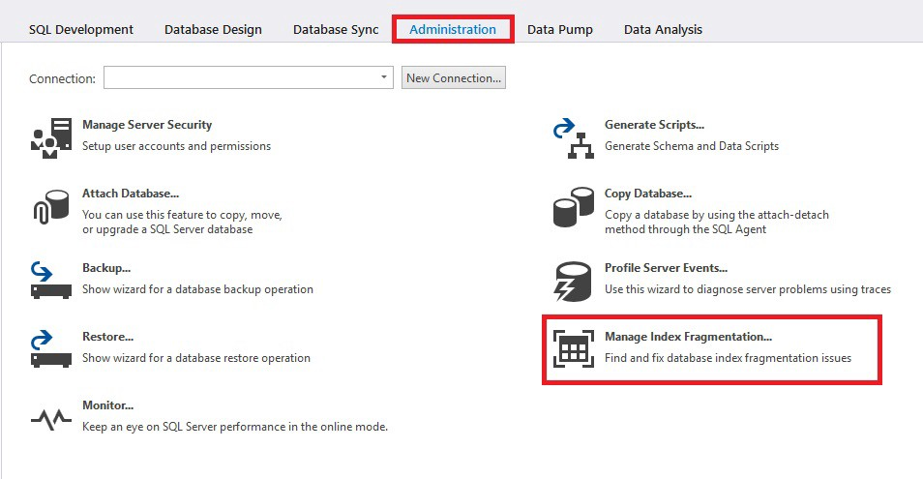
“Manage Index Fragmentation…” selection on the “Administration” tab.
In the window that opens, select the server and click “Options” to configure the settings:

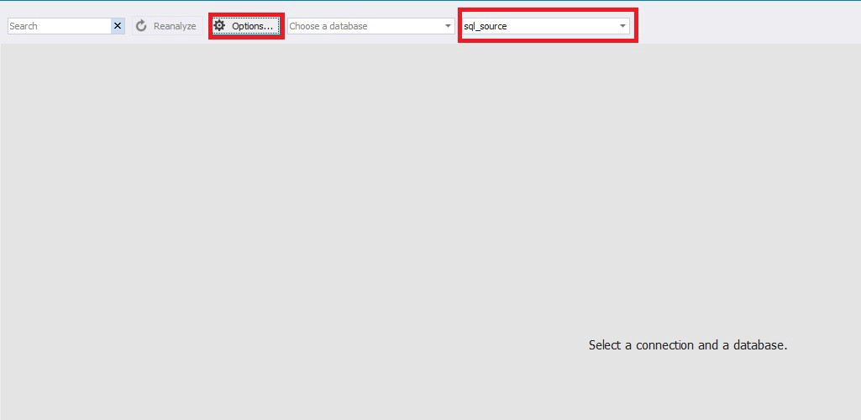
Server selection and settings configuration.
In the options window that appears, set the desired parameters:

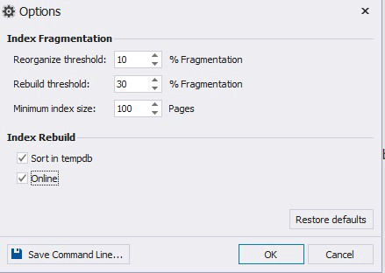
Indexes optimization options.
The results of the settings can be saved as a bat-file by clicking the lower-left button “Save Command Line …”. And you can reset to default settings by clicking the lower-right button “Restore defaults”.
Next, click “OK”.
Now select the database you need:

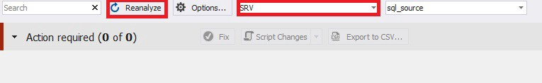
Database selection.
After that, the analysis will start. You can also update the analysis by clicking the “Reanalyze” button.
When the analysis is finished, select the desired indexes for optimization:

Selection of indexes for optimization.
Please note that the analysis result can be downloaded as a CSV file by clicking the button “Export to CSV …”.
Further on, optimization can be carried out in several ways:
- generating a script in a new studio window (in “Script Changes” menu select “To New SQL Window”).
- generating a script to clipboard (in “Script Changes” menu select “To Clipboard”).
- running the optimization directly (click the “Fix” button).

Let’s choose the third method — click the “Fix” button .
After the optimization process is completed, you need to click the “Reanalyze” button again:
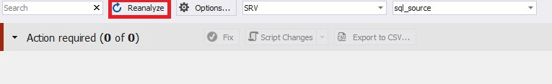
Analysis after indexes optimization.

Conclusion
The analysis of indexes fragmentation level and the extent of statistics obsolescence with subsequent optimization was conducted. It is also clear from the example above that the dbForge Index Manager tool allows you to analyze quickly the level of index fragmentation, as well as generate a database index optimization script.

https://github.com/jobgemws/Projects-MS-SQL-Server-DBA/tree/master/SRV

